**Report 2011CS1011**

**CSL 407 Machine Learning Homework 2**

**Question 1 :**

The plots found in the question are :

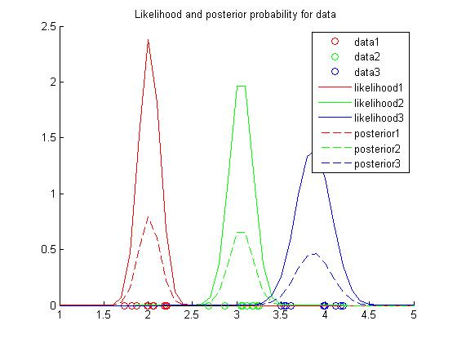

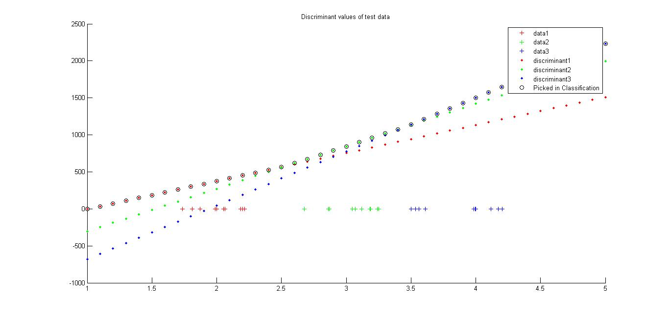

**Question 2 :**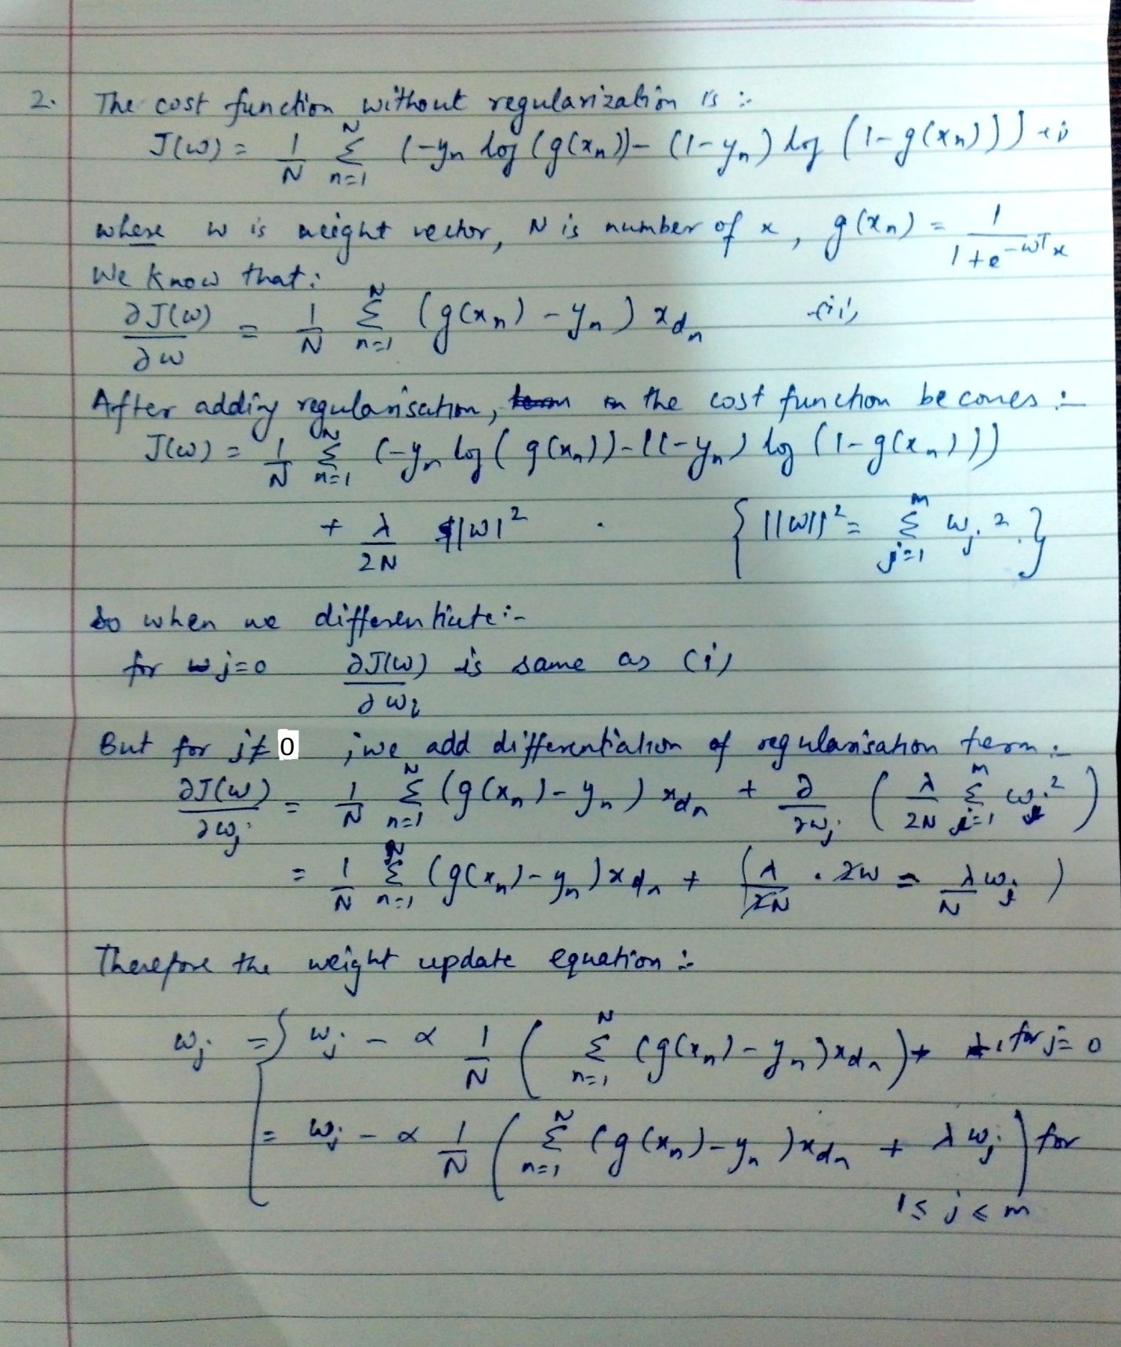

**Question 3 :**

Observation : Graph for varying degree and lambda .

Varying lambda for degree = 2

Lambda = 0.0

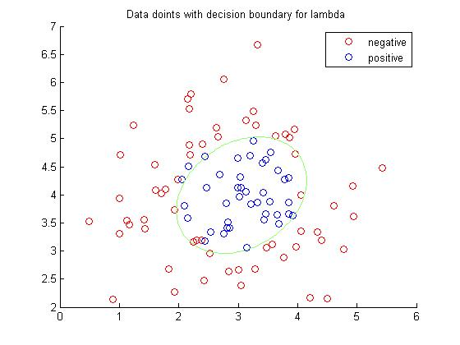

Lambda = 0.5

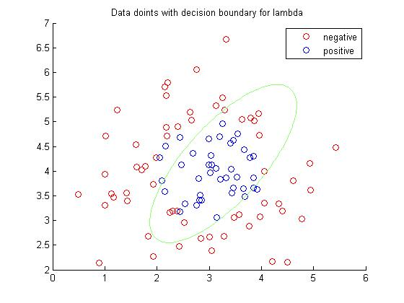

Lambda = 1.0

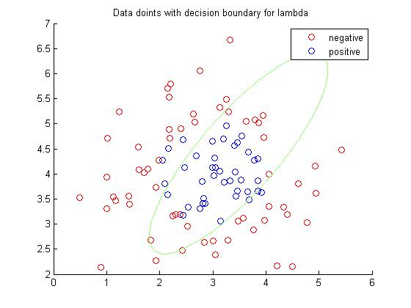

For Degree = 3

Lambda = 0.0

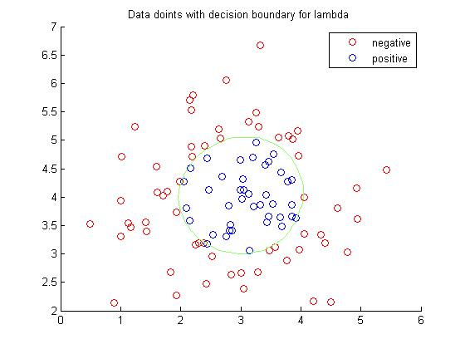

Lambda = 0.5

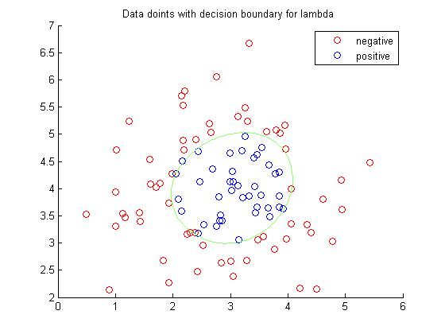

Lambda = 1.0

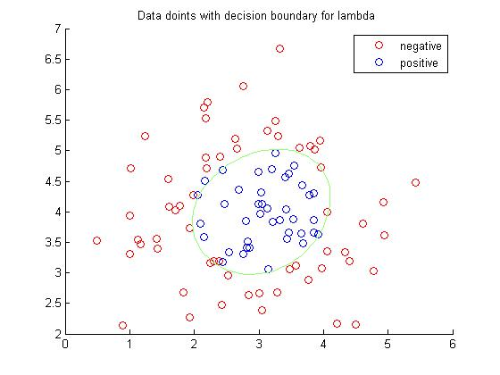

**(ii)**Overfitting happens in the case where value of lambda is low .Example given Lambda = 0.0 Degree 4

We can notice that all the points are separated by decision boundary.

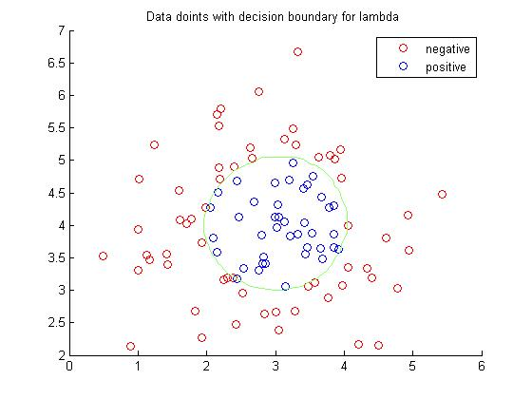

Under fitting happens when there is extra regularization . Example given Lambda = 100.0 Degree = 4.0

We can notice that some significant amount of points are missed by decision boundary.

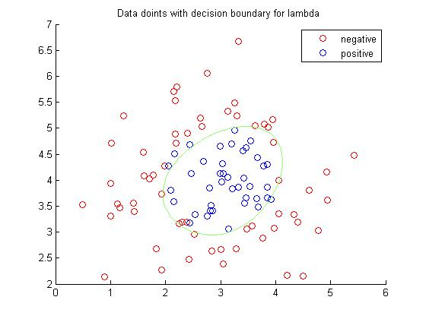

**Question 4 :**

**Solution :** x1 = hours studied, x2 = undergrad GPA, and Y = receive an A

Estimated coefficient , w0 = -8 , w1 = 0.05, w2 =1

1. x1 = 5 x = 7.5

wTx = -8 + (0.05*5) + (1*7.5) = - 0.25

g(wTx) = g(-0.25) = 0.4378.

1. Probability of student getting A in class = 0.6

Therefore g(wTx) = 0.6

So, wTx = 0.4054

-8 + (0.05*x1) + (1*7.5) = 0.4054

x1 = 18.108

Student need to study for 18.108 hours .